Please complete the following for skills demo 2: Adding or Upgrading hardware (use more space as required)

- State the health and safety precautions you have taken to complete this demonstration.

Before adding or upgrading hardware to a device, ensure that there are no spills and the area around the machine is free. Make sure that all power to the machine is off and unplug all the cables connected to the machine. Before adding any hardware to the machine, earth yourself to avoid electrical discharge.

- What preparation regarding drivers and system specification did/should you take?

- Form Factor
- Ensure that the network card will fit in the slot that you intended to add it too
- Power requirements
- Check System requirements
  - Confirm that the system you’re adding the network card too meets the minimum
- Software requirements
  - Operating system
- Support and advice

- What steps have you taken to physically add the hardware component to the system?

Consider the health and safety precautions before adding the hardware component to the system; this includes earthing yourself to avoid frying the network card. Power down the PC and remove the power cord. Lay the computer on its side and open the case. Find an available PCI slot on the motherboard and remove slot insert if one exists. Carefully remove the network card from its envelope and slide it into the slot. Seat the card in the slot firmly along the length of the card. Close the computer case and plug the computer back in and power it up.

- How do you install drivers using plug and play as well as manual install?
Plug and Play
Click start and right click on Computers and select manage. This will bring the Computer Management window up, and select Device Manager Check if the device installed correctly (this will be under the tab Network adapters), if there is a conflict, a yellow caution sign will be beside the name of the card. Right click on the device and search automatically. The computer will then browse for the updated drivers, if they are present the drivers will be updated.

Manual
Click start and right click on Computers and select manage. This will bring the Computer Management window up, and select Device Manager Check if the device installed correctly (this will be under the tab Network adapters), if there is a conflict, a yellow caution sign will be beside the name of the card. Select the device and right click on the name, then click Update Driver Software, this will open up a window prompt. Select browse my computer for driver software. Click browse and locate your driver, when it’s finished click next and the install process will begin.

- What difficulties can occur, how are they recognised and what can be done to resolve them?
A Blue Screen of Death can occur, this can be resolved by pressing F8 on boot and selecting the option to run last good configuration, this will bring the computer back to its original state before any conflict occurred.

- Paste a print screen of device manager here showing the hardware device added without any conflicts.
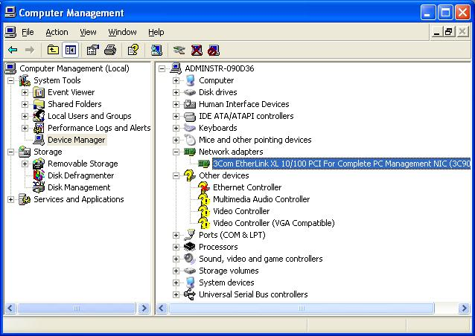

- Paste a print screen of showing the list of IRQs for the system with the device included.
